ElderSource Institute Launches Virtual Caregiver
Support Groups

ElderSource Institute has launched the Virtual Caregiver Support Group giving caregivers a safe place to share information, ask questions, voice personal feelings and stories. The support group will make it possible for caregivers to connect face-to-face in real time with other caregivers using today’s technology.

The groups will consist of 10-12 participants with each session lasting 60 to 90 minutes and will be facilitated by a skilled moderator who will guide the participants through their conversations.

Any caregiver living in northeast Florida can sign up; however the group will be focused on those who feel they cannot leave their loved one to attend a support group but would benefit from participating in one.

Caregivers need to have Internet access and some form of technology to participate such as a smart phone, tablet, iPad, desk top computer or laptop computer. A video conferencing app will be used and the facilitator will instruct the caregiver on how to use the app.

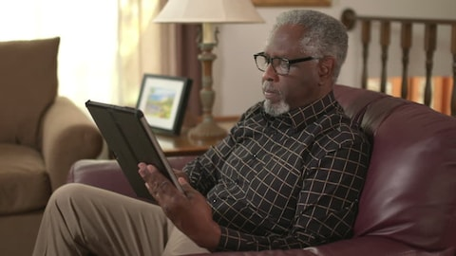
Studies show that over 66% of caregivers feel isolated. Support groups can offer a safe place to share information, ask questions, voice personal feelings and stories. “While friends continue on their daily routines, some caregivers feel alone in their caregiving duties and often are isolated from friends and social activities, feeling disconnected,” said ElderSource Institute CEO Linda Levin. “Caregivers without support from other caregivers in similar situations may feel as though no one really understands their situation,” she added.

The Virtual Caregiver Support Group is funded from the proceeds of the annual ElderSource fundraising event, A Night with the Stars.
For more information on how to participate or to make a referral for the Virtual Caregiver Support Group, please email Louise Starmann at louise.starmann@eldersourceinstitute.org or Linda Levin at linda.levin@eldersourceinstitute.org.

